**Princess Sumaya University for Technology**

**King Abdullah II Faculty of Engineering**

**Computer Engineering Department**



|  |
| --- |
| **EMBEDDED SYSTEMS.**  **PROJECT ON PIC16F877A.**  **GROUP (24).**  **Automated Card Distribution** |

**Authors: Supervisor:**

**Ahmad melehm 20190922 Dr. Bealal Sababha**

**Basil Alsarayra 20191073 Dr.Anastasia Gharib**

**Abdalrhman musleh 20200308**

***Abstract***

The "Automated Card Distribution System using PIC 16F8778" represents a technological innovation in the domain of card games.

This project introduces a compact and efficient solution that automates the card distribution process, thereby optimizing gameplay and enhancing the overall experience for participants.

The core components of the system include the PIC 16F8778 microcontroller, stepper motor, servomotor, and a Sharp IR sensor.

The stepper motor facilitates a 360-degree rotation of the cardholder, while the servomotor efficiently propels cards from the holder to the table.

The integration of the Sharp IR sensor ensures precise detection of the number of players and their positions, contributing to an accurate and dynamic card distribution process.

This report provides a comprehensive overview of the system architecture, methodology employed, and the achieved results, highlighting the successful implementation of an automated card distribution system that seamlessly enhances the gaming experience.

Table of Contents

1 Introduction 2

2 Procedure and Methods 3

3 Results . 6

4 Problems………………………………………………………………………….………………8

5 Conclusions 8

# Introduction

This automated system aims to revolutionize traditional card game setups, providing a seamless and dynamic distribution process that eliminates the manual effort associated with handling and dealing cards. Beyond its functional aspects, the project reflects a commitment to innovation in gaming technology, enhancing user engagement and fostering an immersive gaming experience.

In this introduction, we will delve into the rationale behind the project, the key components that drive its functionality, and the potential benefits it brings to the world of card gaming. Through this exploration, we aim to present a compelling case for the relevance and significance of the Automated Card Distribution System in transforming conventional card game interactions.

**1.1 OBJECTIVES**

* To use knowledge we gained in the course to build an embedded system.
* Learn how to the hardware components with each other.
* Write a code that is compatible with the hardware.
* Use our soft skills as a team and develop new skills.

# Procedure and Methods

**• Design how our embedded system is going to work.**

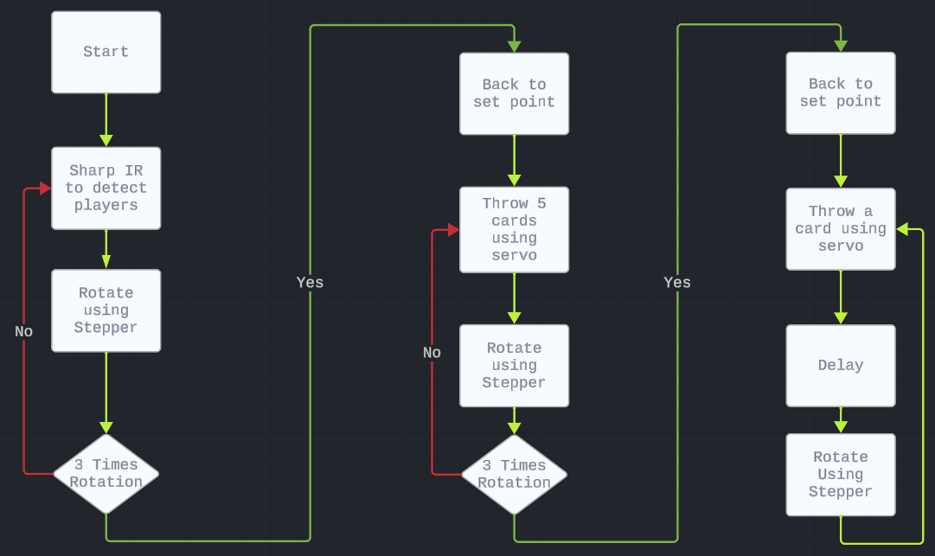

**The Automated Card Distribution System operates through a systematic process facilitated by the Sharp IR sensor, stepper motor, and servomotor. Initially, the sensor detects players, prompting the stepper motor to move to the next set point. This sequence repeats to accommodate additional players. In the second round, the servo dispenses five cards to a player, and the stepper advances to the next player. From the third round onwards, the servo dispenses one card with a 20-second delay, after which the stepper rotates to the next player. This cyclic process optimizes card distribution, enhancing the gaming experience.**

**• Design a block diagram to know which components we will use for the project.**

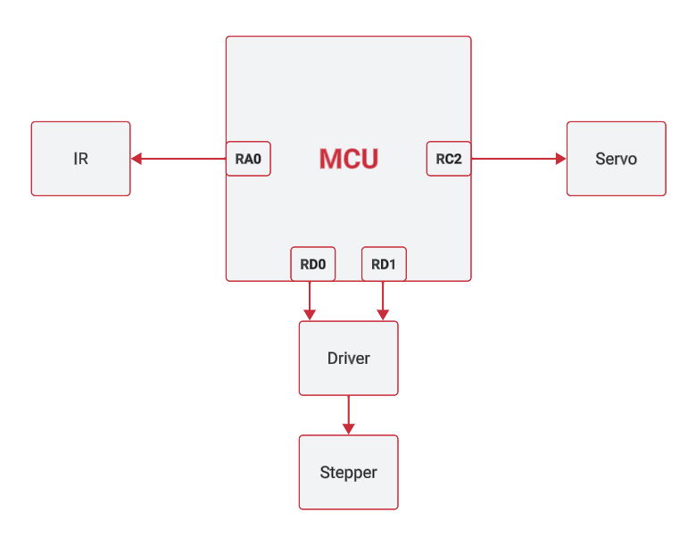

The stepper motor facilitates a 360-degree rotation of the cardholder, while the servomotor efficiently propels cards from the holder to the table.

The integration of the Sharp IR sensor ensures precise detection of the number of players and their positions, contributing to an accurate and dynamic card distribution process.

**• Make an Electrical design.**

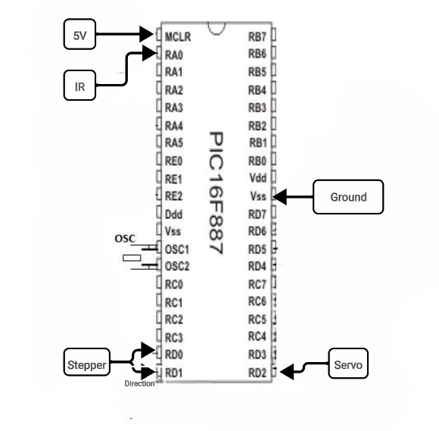

The Electrical design is made with simple chart app to simulate the circuit to make sure that everything can work perfectly fine electrical wise.

**3 Results**

After assembling all the hardware and software components and installing them on the base with the game, we got our final product as shown in the pictures below:

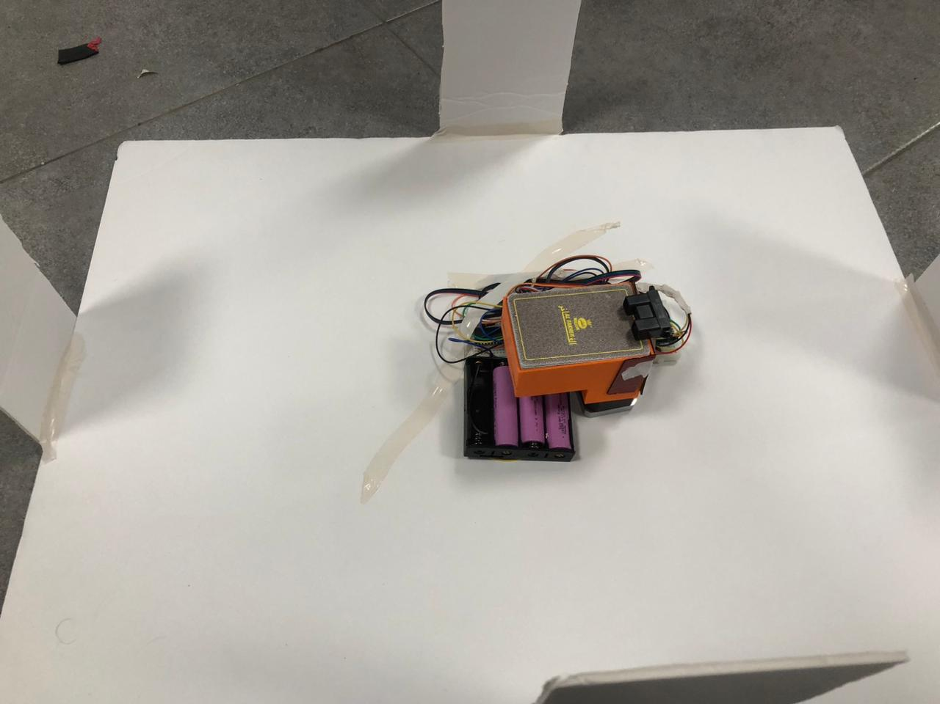

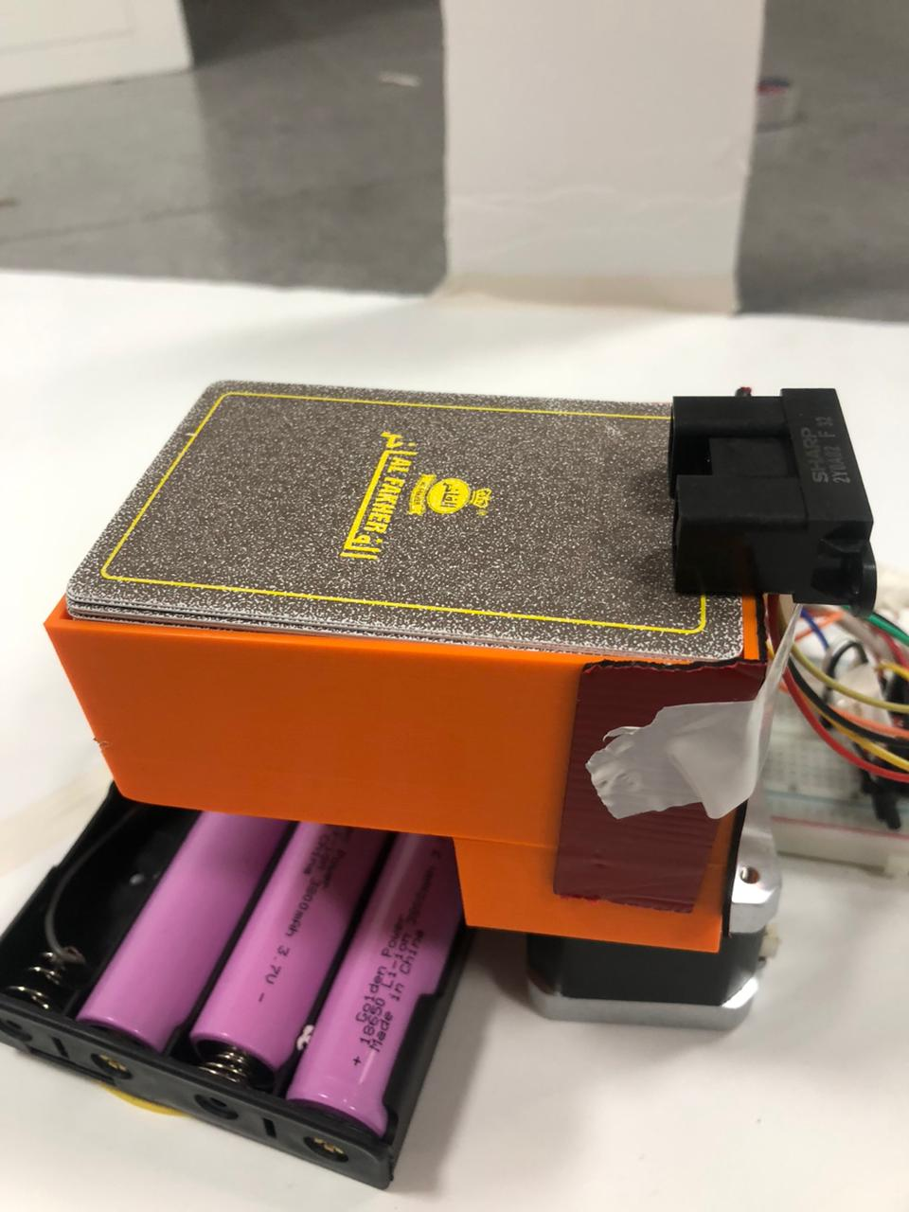

# 4 Problems we faced

**Motor Synchronization:**

* Achieving seamless coordination between the stepper motor and servo motor movements for efficient card distribution.
* Minimizing delays or hitches in the motor operations during gameplay.

**Code Optimization:**

* Writing and optimizing the PIC 16F8778 microcontroller code to ensure efficient communication and control of the motors.
* Resolving any potential bugs or glitches in the programming logic.

# 5 Conclusions

In summary, the development of the Automated Card Distribution System using PIC 16F8778 marks a significant advancement in enhancing card game dynamics. Leveraging technologies like the Sharp IR sensor and stepper and servomotors, the system streamlines card distribution, offering a seamless and adaptable gaming experience.

In essence, this project exemplifies the fusion of technology and gaming, showcasing how automation can enhance traditional experiences. The system promises to redefine card game dynamics, providing both convenience and a novel dimension to the enjoyment of playing cards.